Project - SZ Tech Pvt Ltd

Step 1 : implementation Project Creation

Navigation : setup and maintenance> Tasks(hamburger right most side)> manage implementation project> create new implementation project

Fields
Name: SZ Tech Pvt. Ltd.
Code: SZ_TECH_PVT_LTD
Assigned To: HCM_IMPL

Create and Enter in a Project.

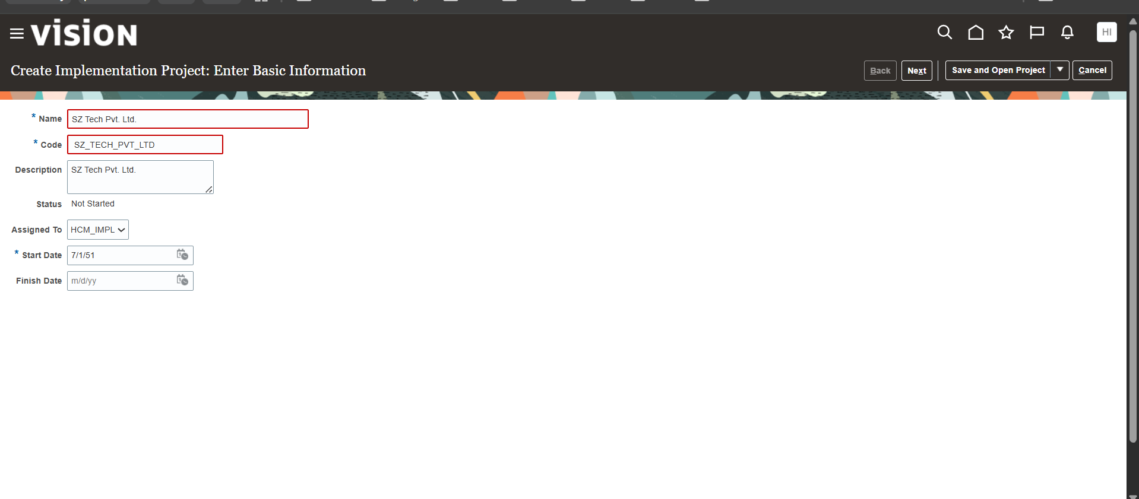

Step 2 : Reference Data Sets Setup : Manage Reference Data Sets

Add new Task list as “Define Reference Data Sharing for Human Capital Management “
Created custom Reference Data Sets to govern data sharing across Business Units and Set-Enabled Objects.
- Set Code: SZ_RDS
- Set Name: SZ_RDS

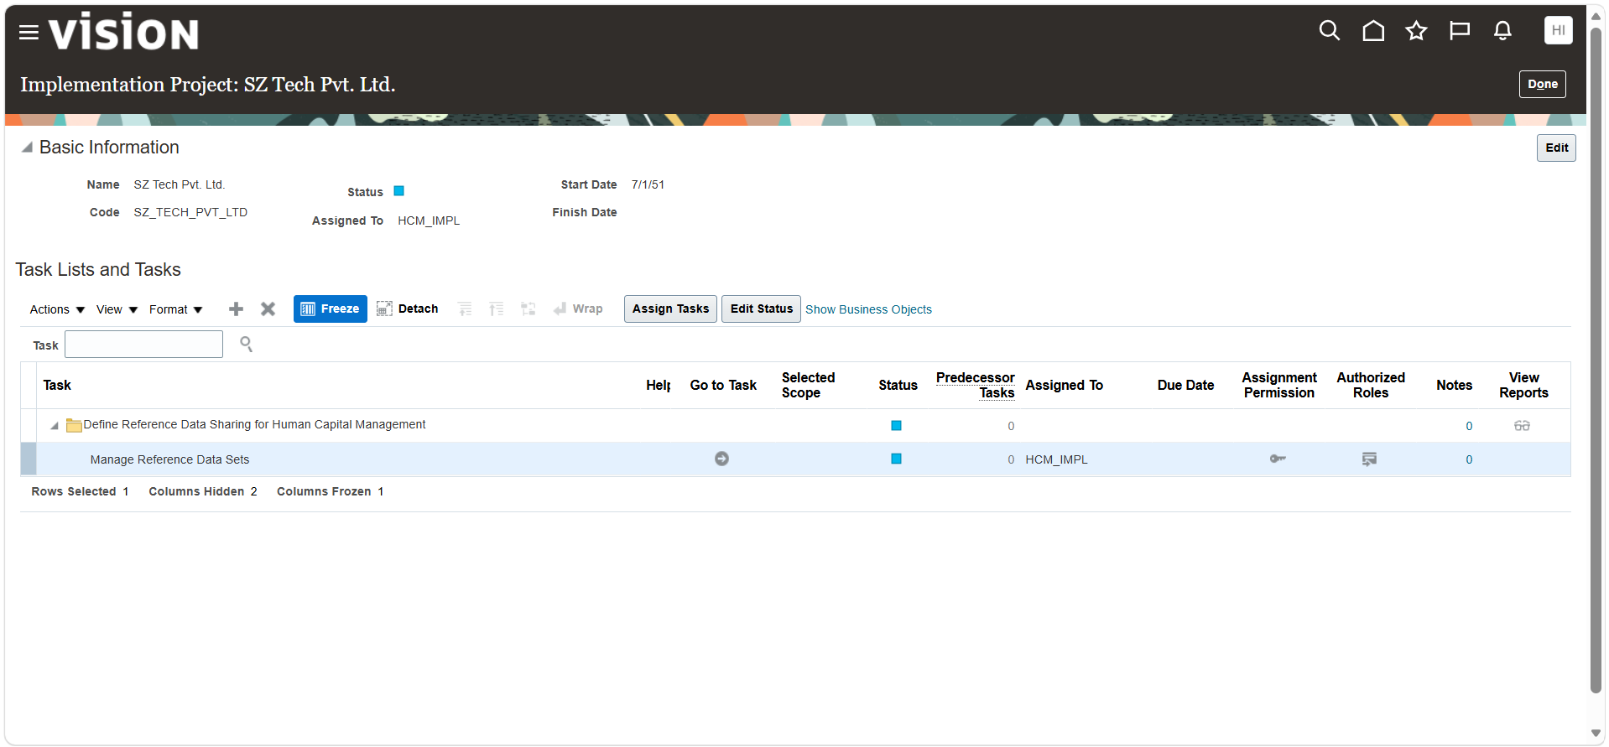
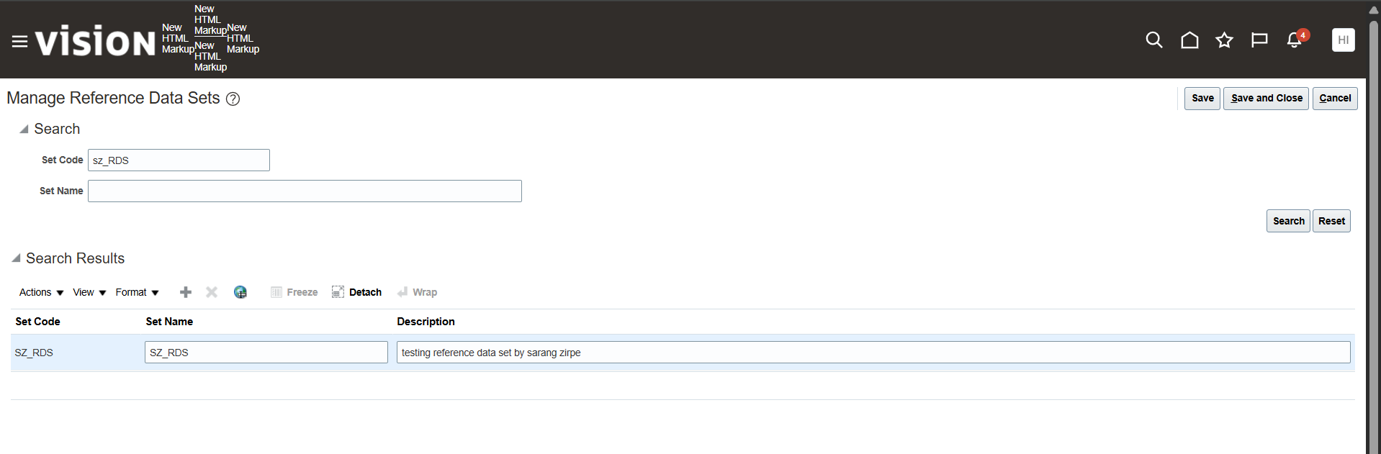

Step 3 : Legislative Data Groups (LDG) : Manage Legislative Data Groups.

Define multi Country Legislative Data Groups for the support of statutory reporting and payroll

US LDG : SZ_US_LDG | Country : United States | Currency : US Dollar
India LDG : SZ_IND_LDG | Country : India | Currency : Indian Rupee
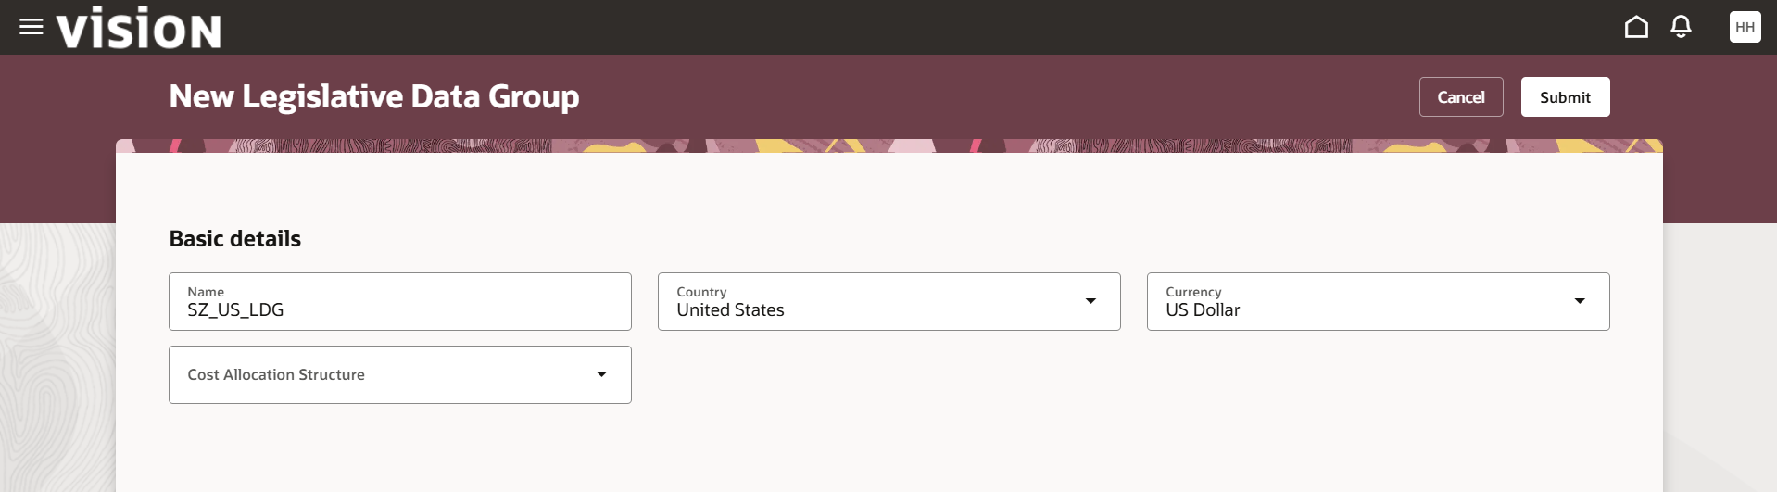

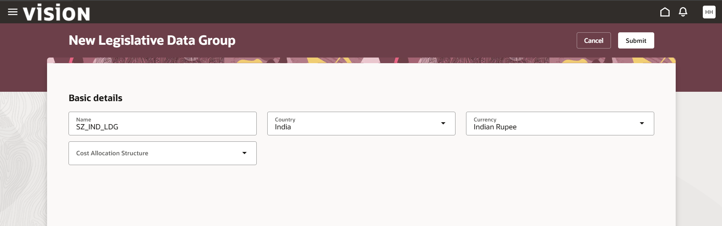

Step 4 : Legal Jurisdiction & Authority Setup

Add a task named Manage Legal Judi..
Its legal structure definition to establish legal compliance structures for us operation

- Add a task named ”Manage Legal Judi..
- It's a legal structure definition to establish legal compliance structures for US operations.

- Legal Jurisdiction Name : SZ_US_LJ | Territory : United States | legislative Category: Commercial Law
- Legal Authority Name: SZ_US_LA | Tax Authority Type: Collecting the reporting
- Legal Address: YU LINE 4, TEXAS CITY, IL Saline

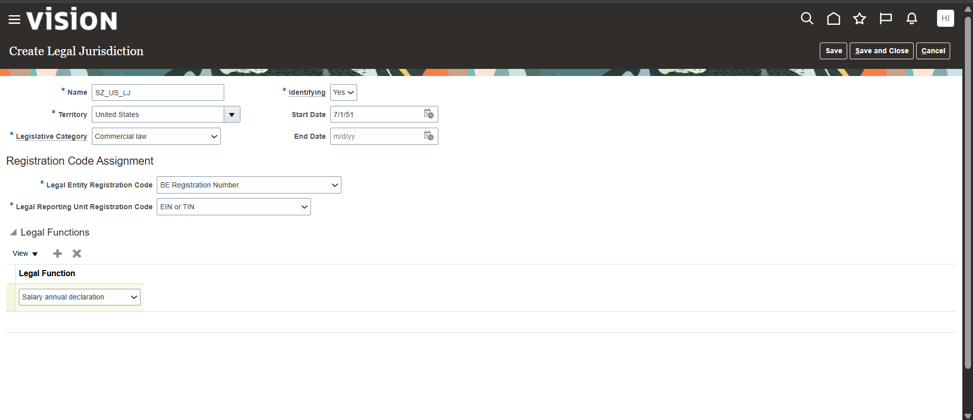
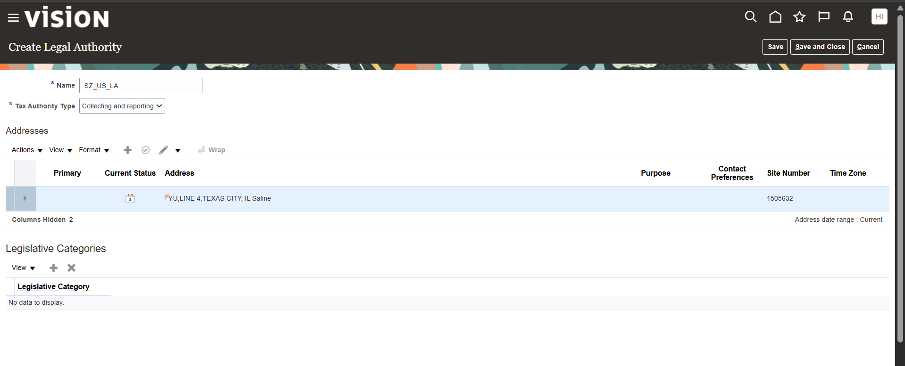

Step 5 : Legal Entity and Calculation Card:
manage Legal Entity & HCM Information.
Created the primary Legal Entity and Associated statutory configurations.

- Legal Entity Name: SZ_US_LE | Identifier : SZLE9763
- Classification: Selected both Payroll Statutory Unit (PSU) and Legal Employer
- Employment Model : 2 Tier - Single Contract - Single Assignment
- Associated LDG : SZ_US_LDG
- Calculation Card: created calculation rules for Tax Reporting and Payroll Statutory Unit. (Effective Date :1/7/51)
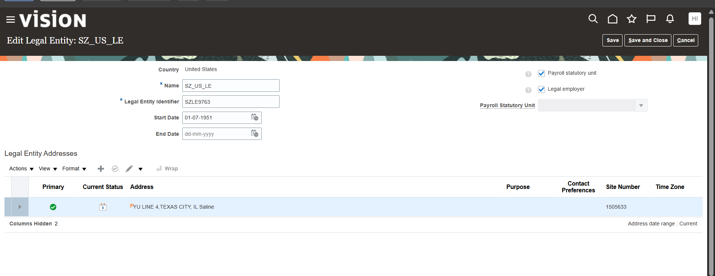
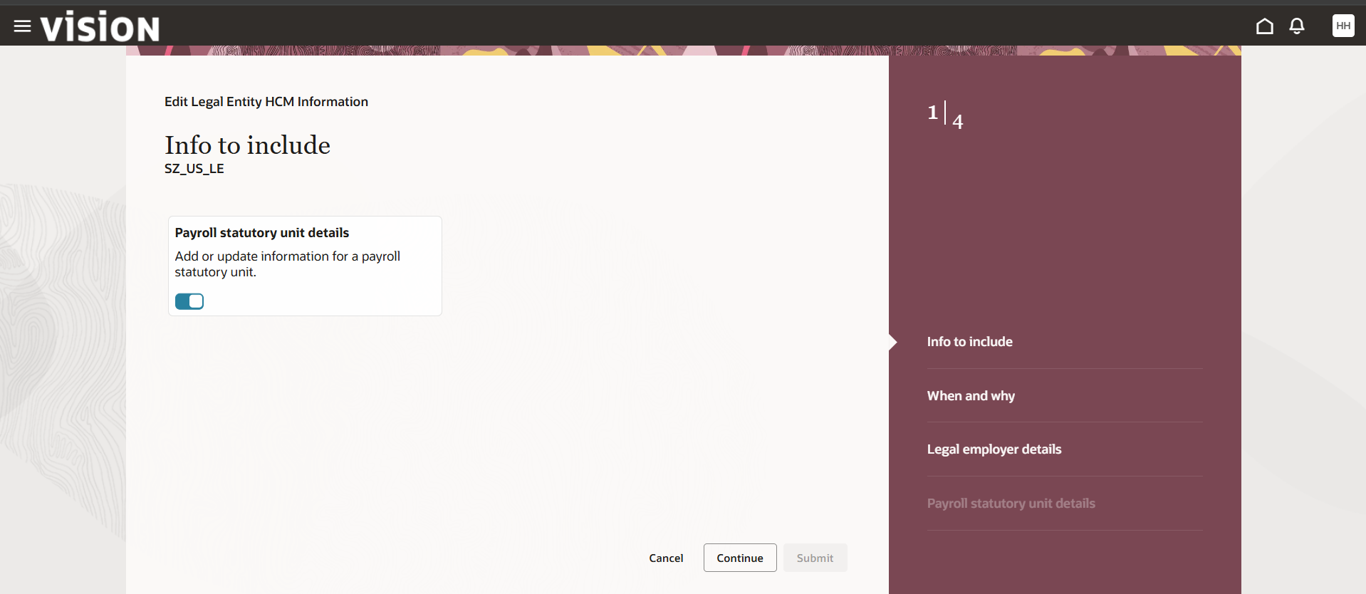
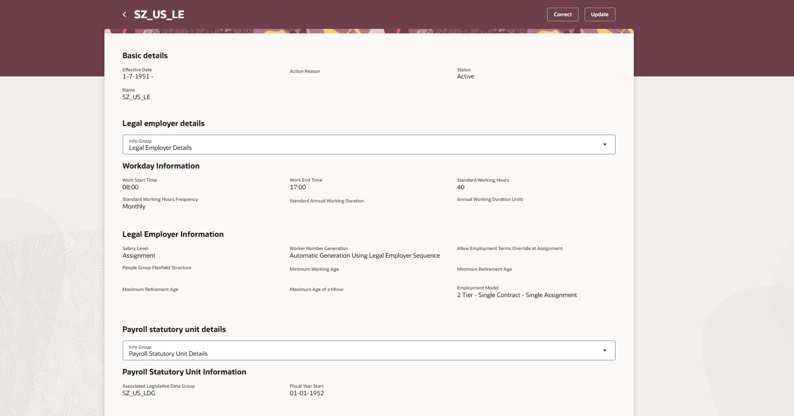
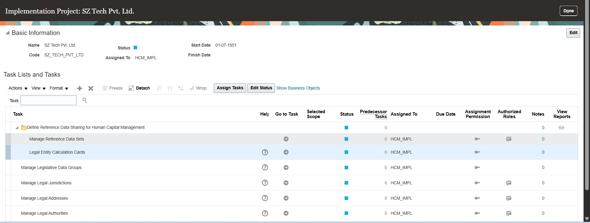
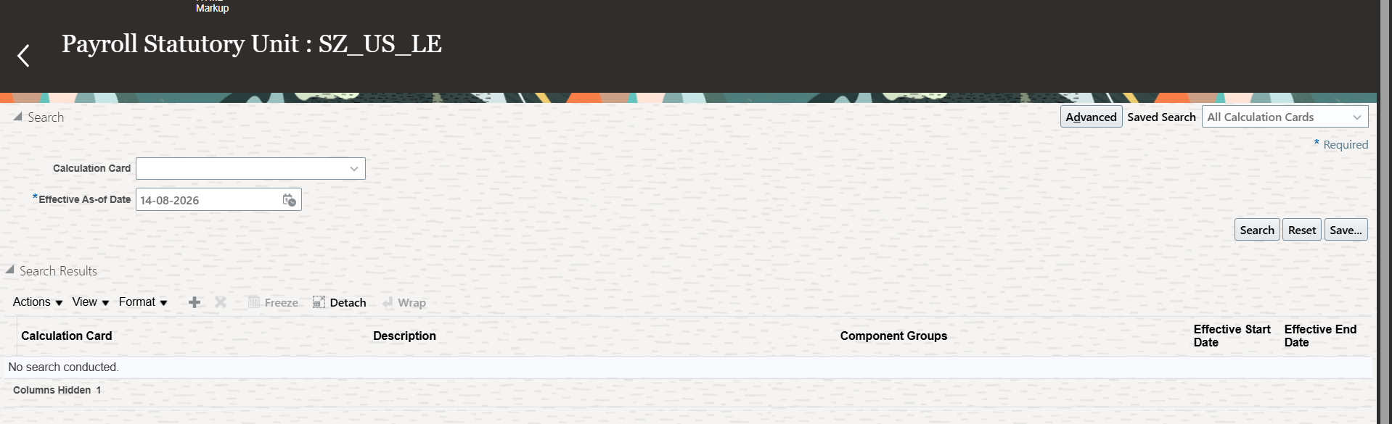
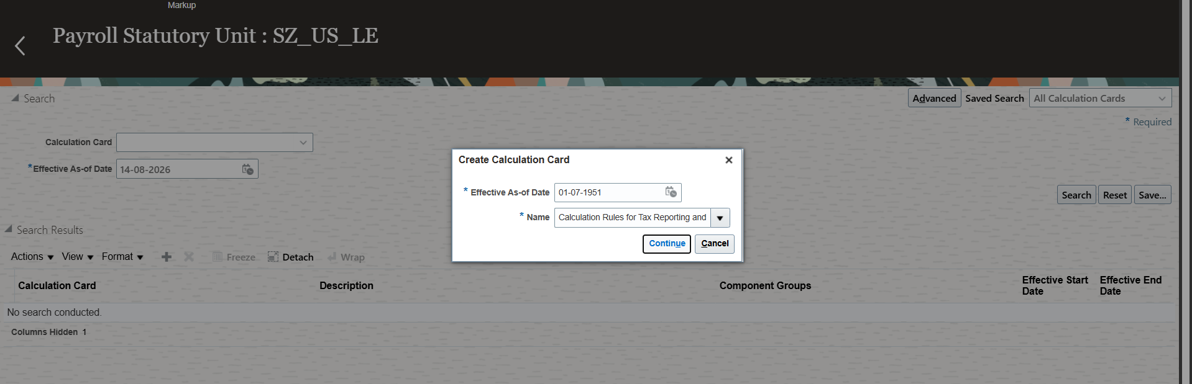
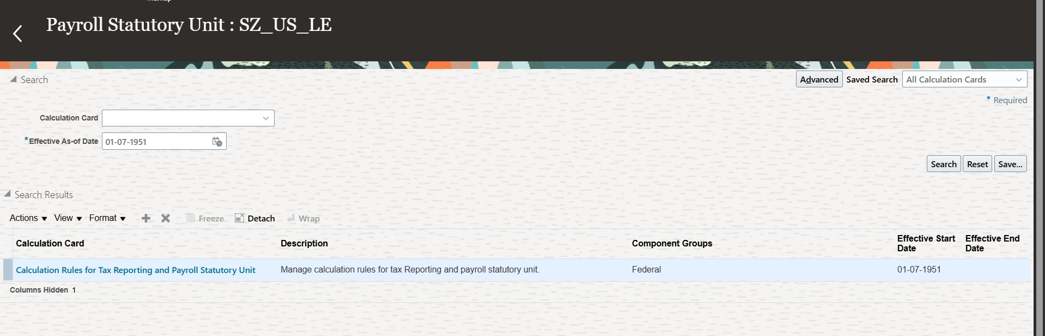
Step 6 : Legal Reporting Unit(LRU) Configuration : Manage Legal Reporting Units.
Defined Legal Reporting Unites for statutory Tax reporting

- LRU Name : SZ_US_LE
- LRU Classification : Selected Tax Reporting Unit and Reporting Establishment
- Calculation Card: Created Calculation Rules for Tax Reporting and Payroll Statutory Unit attached to the TRU.

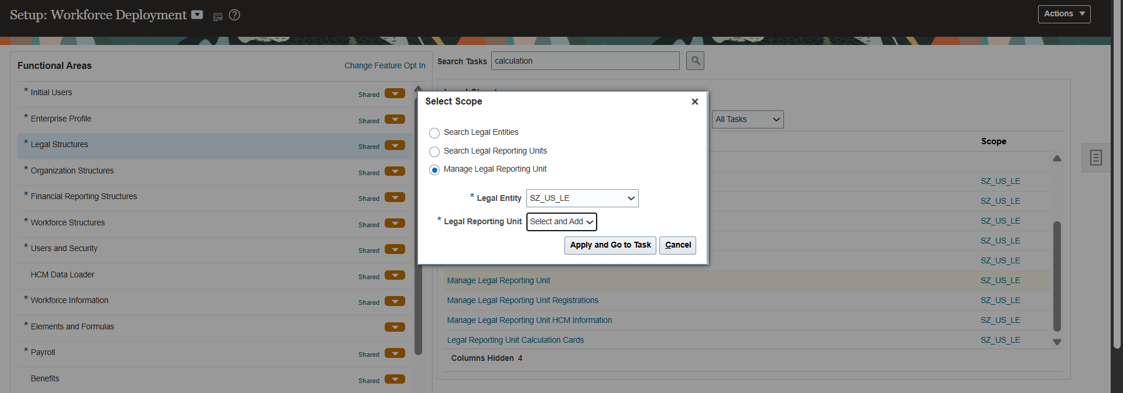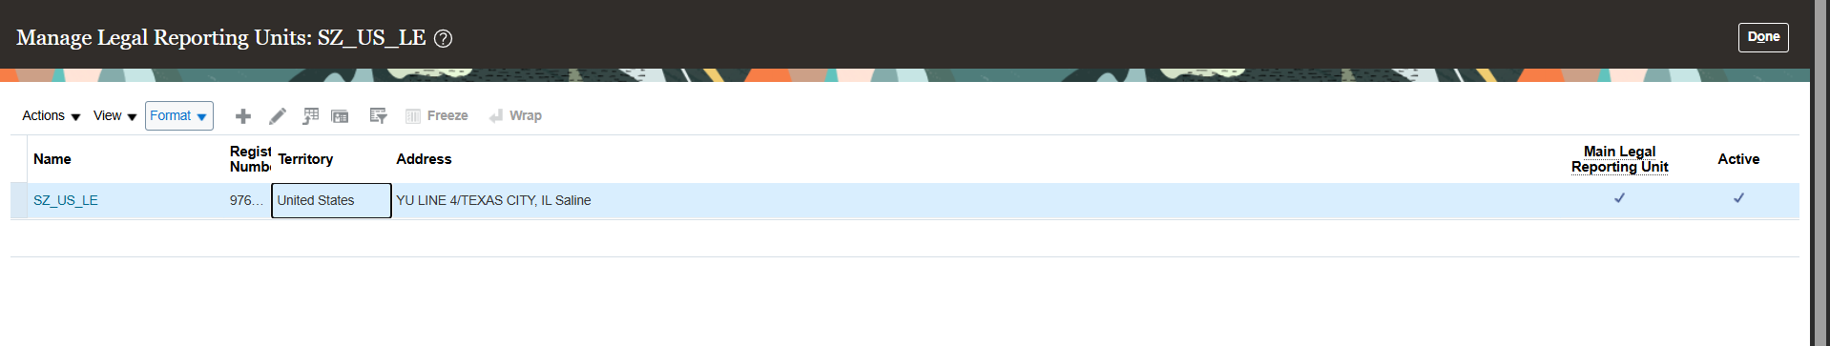
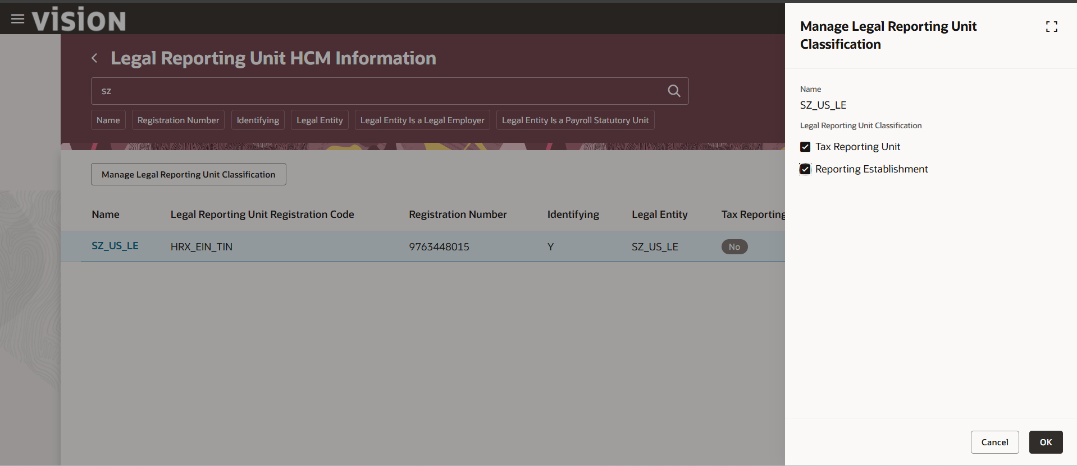
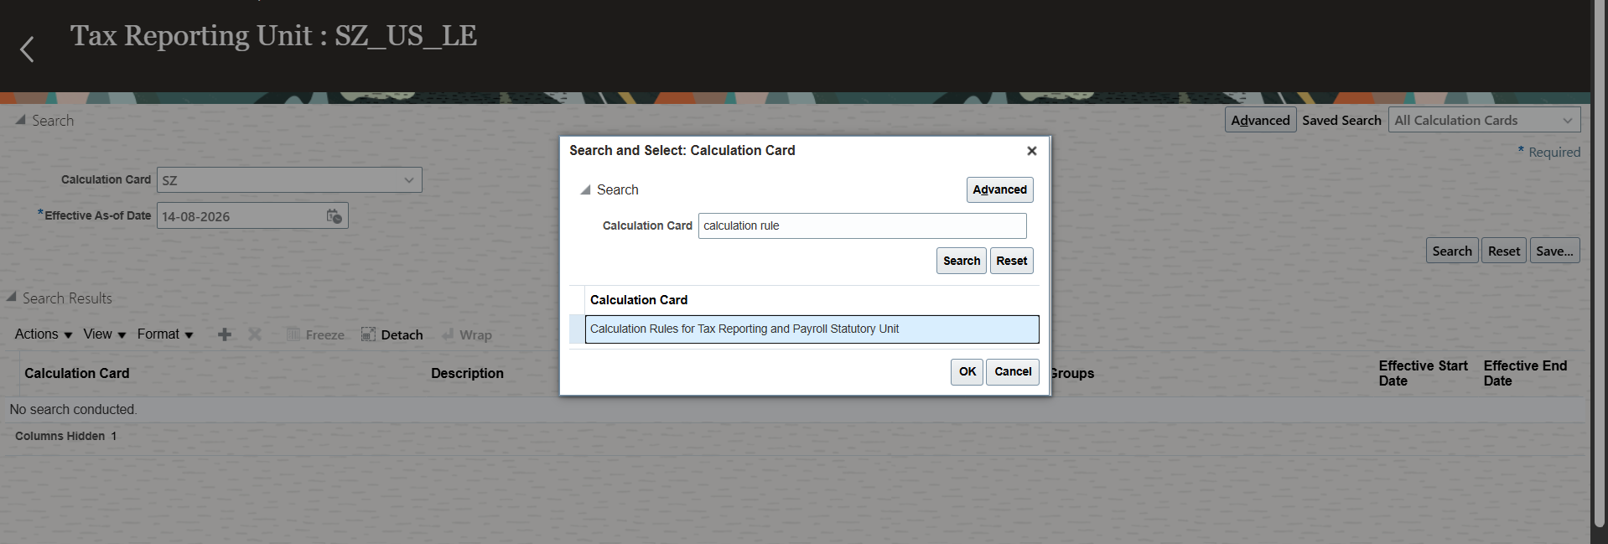

Step 7 : Primary Ledger Creation and Alignment : Define Accounting Configuration.
Configured Financial Ledger Mapping for HCM integration

- Primary Ledger Name : SZ_PL
- Chart of Accounts : IN Chart of Accounts
- Accounting Calender : Annual Calender
- Currency : USD - US Dollar
- Accounting Method : Us Federal
- Legal Entity Method : US Federal
- Legal Entity Assignment : Mapped SZ_US_LE to primary Ledger SZ_PL

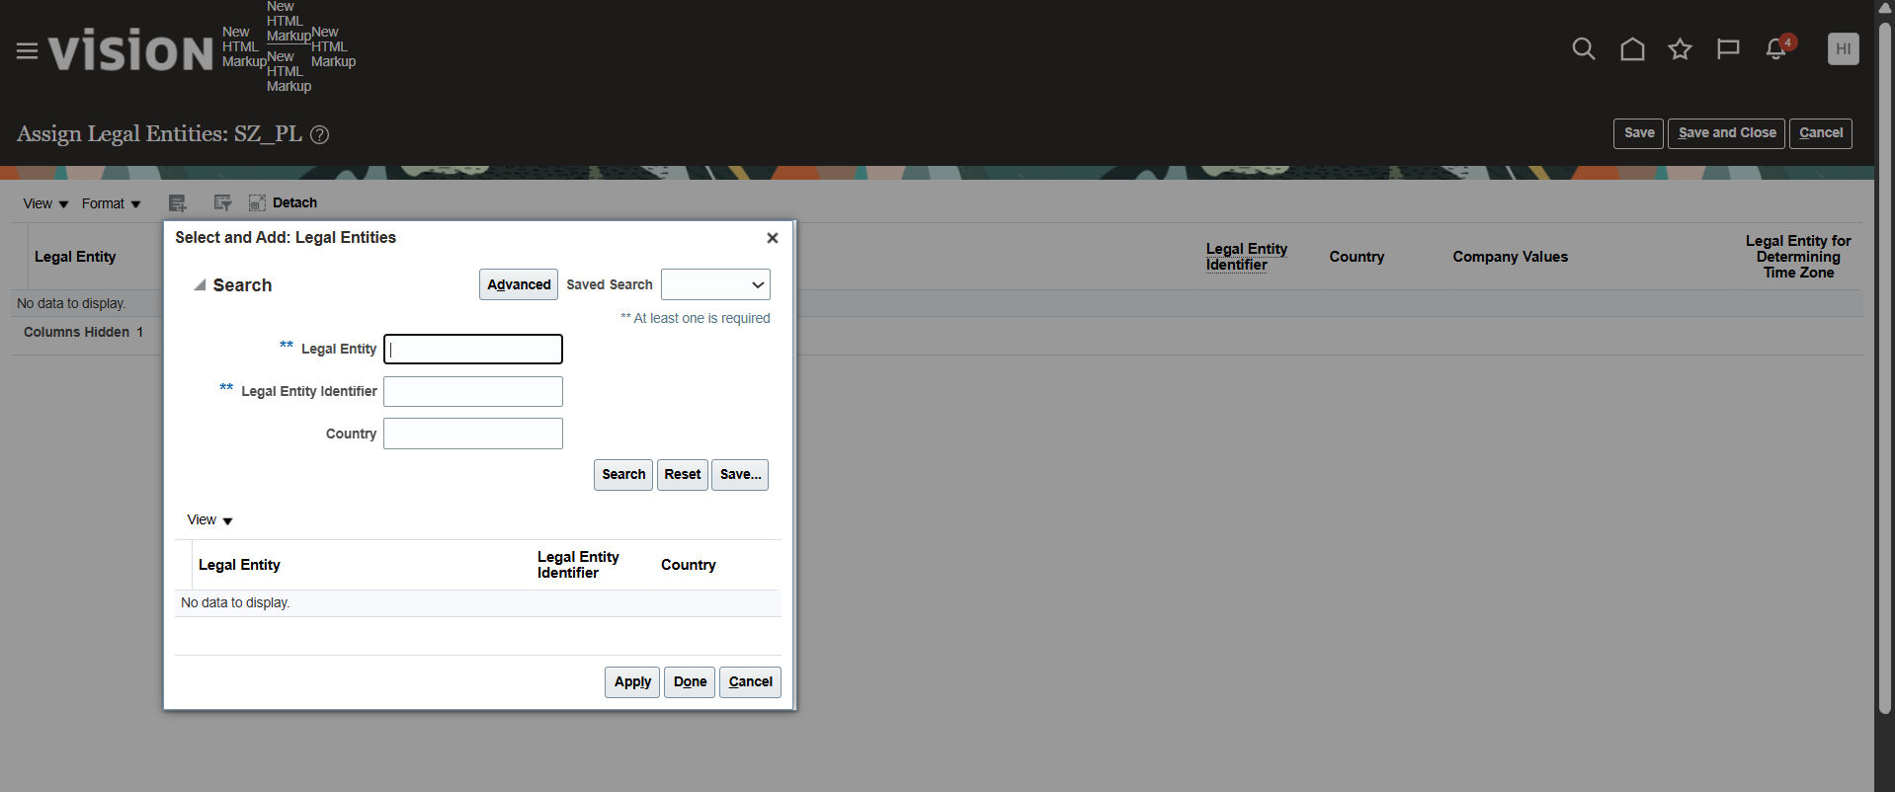

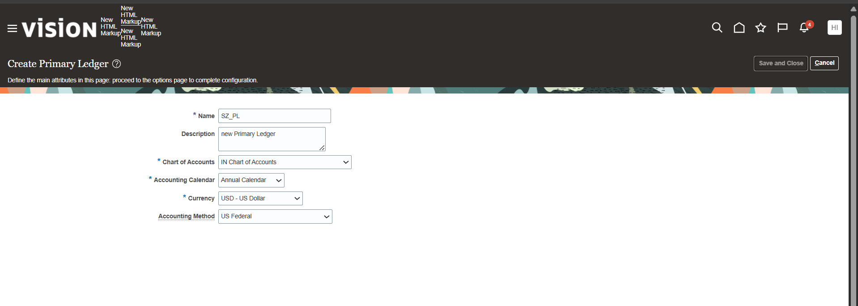
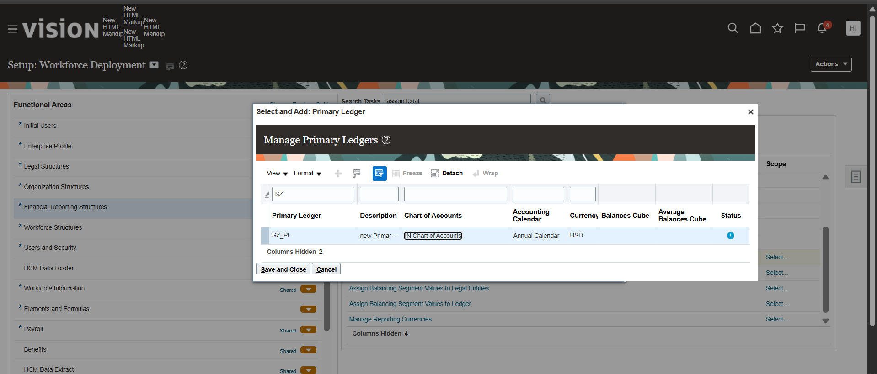

Step 8: Business Unit Setup:Define Business Units.
Established operational Business Unit and attached custom Reference Data Sets.

- BU Name: SZ_US_BU
- Default Set: SZ_SET_CODE
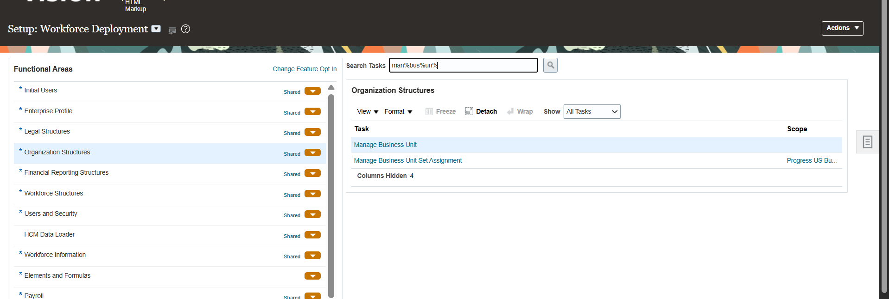
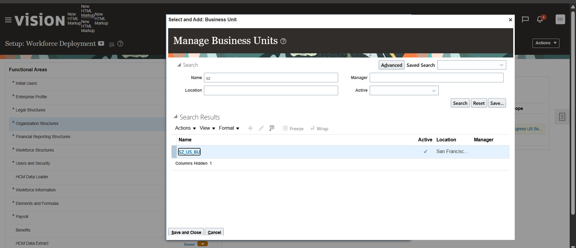

Step 9 : Department Creation: Manage Department

Created core functional departments liked to SZ_RDS

- SZ_HR_DEPARTMENT( Title : HR Department)
- SZ_IT_DEPARTMENT(Title: IT Department)
- SZ_SALES_DEPARTMENT(Title: Sales Department)

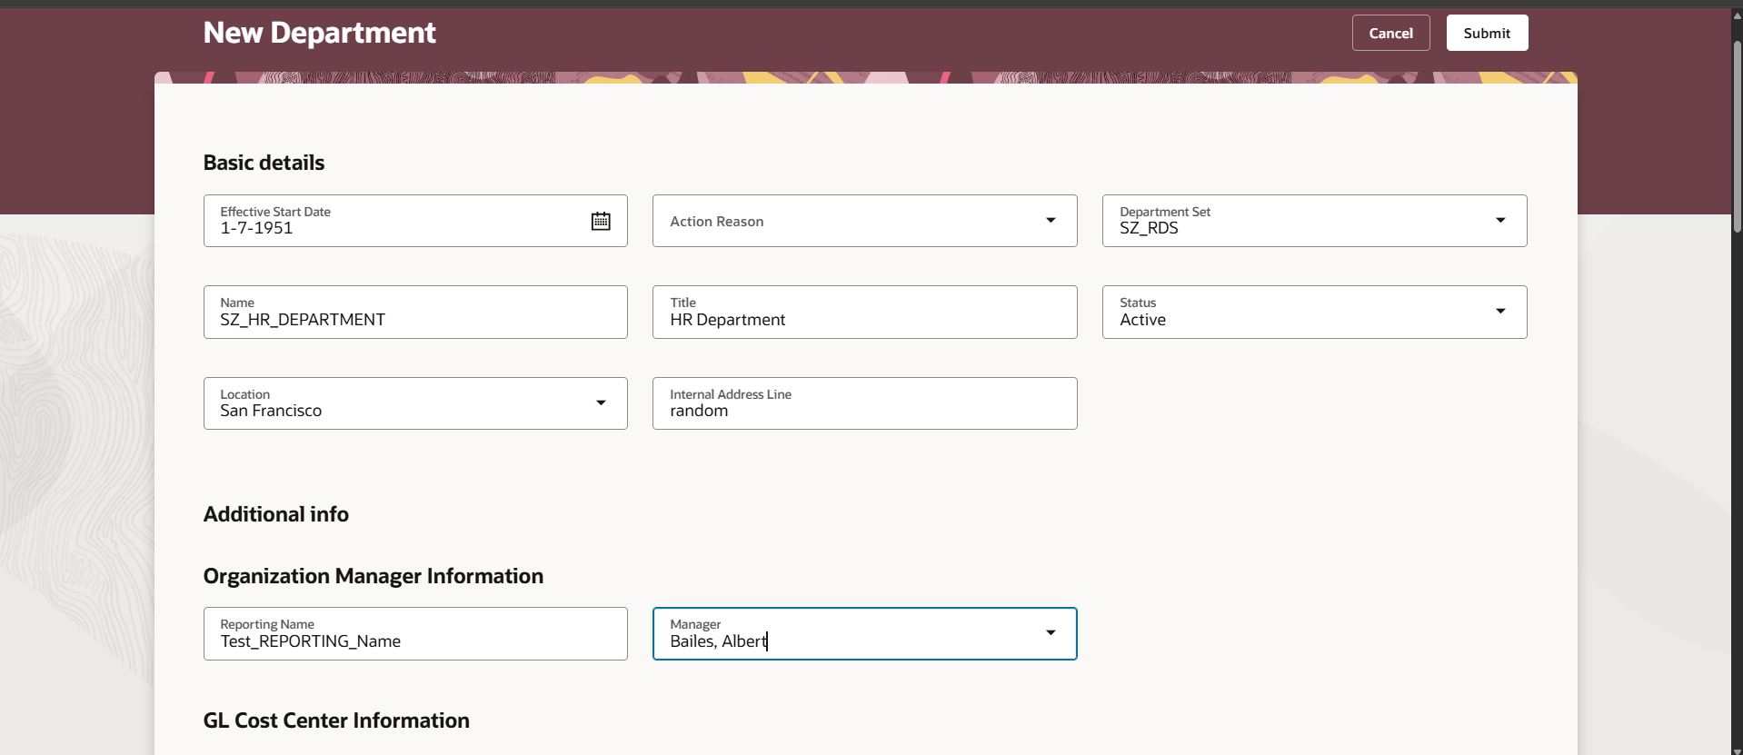

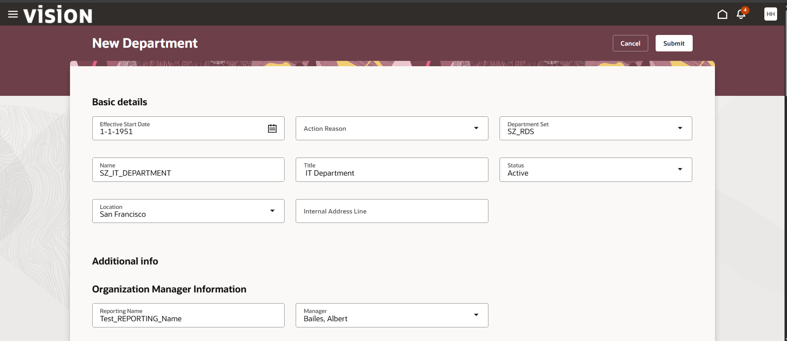
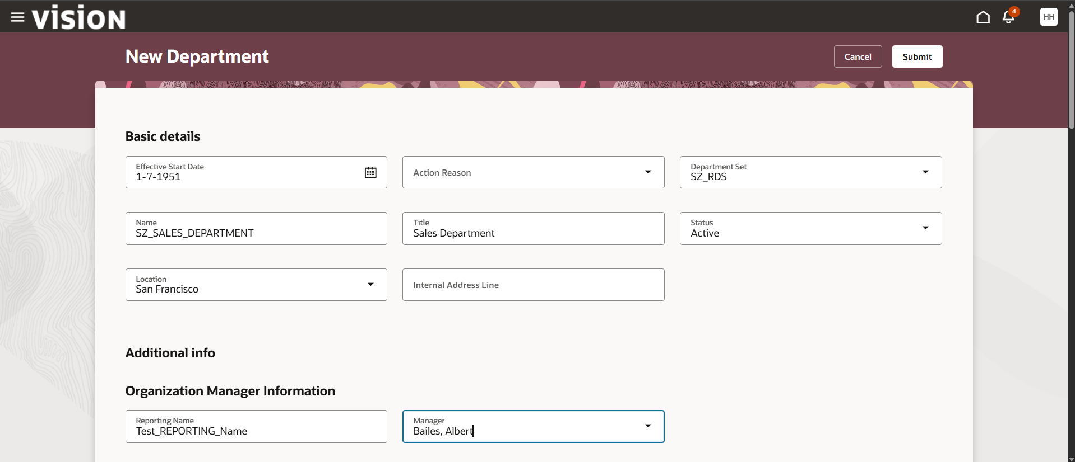

Step 10: Department Tree and Hierarchy Configuration : Manage Department Trees
Built Validate,and flattened the organizational tree structure.

- Tree Name : SZ_Tech_Pvt_Ltd
- Tree Version Name : SZ_Departments (Effective Start Date : 1/7/51)
- Node Assignment : Added SZ_HR_DEPARTMENT, SZ_IT_DEPARTMENT, SZ_SALES_DEPARTMENT
- Validation and Fattening : Run tree audit(14 of 14 validators pass) and completed online row flattening successfully

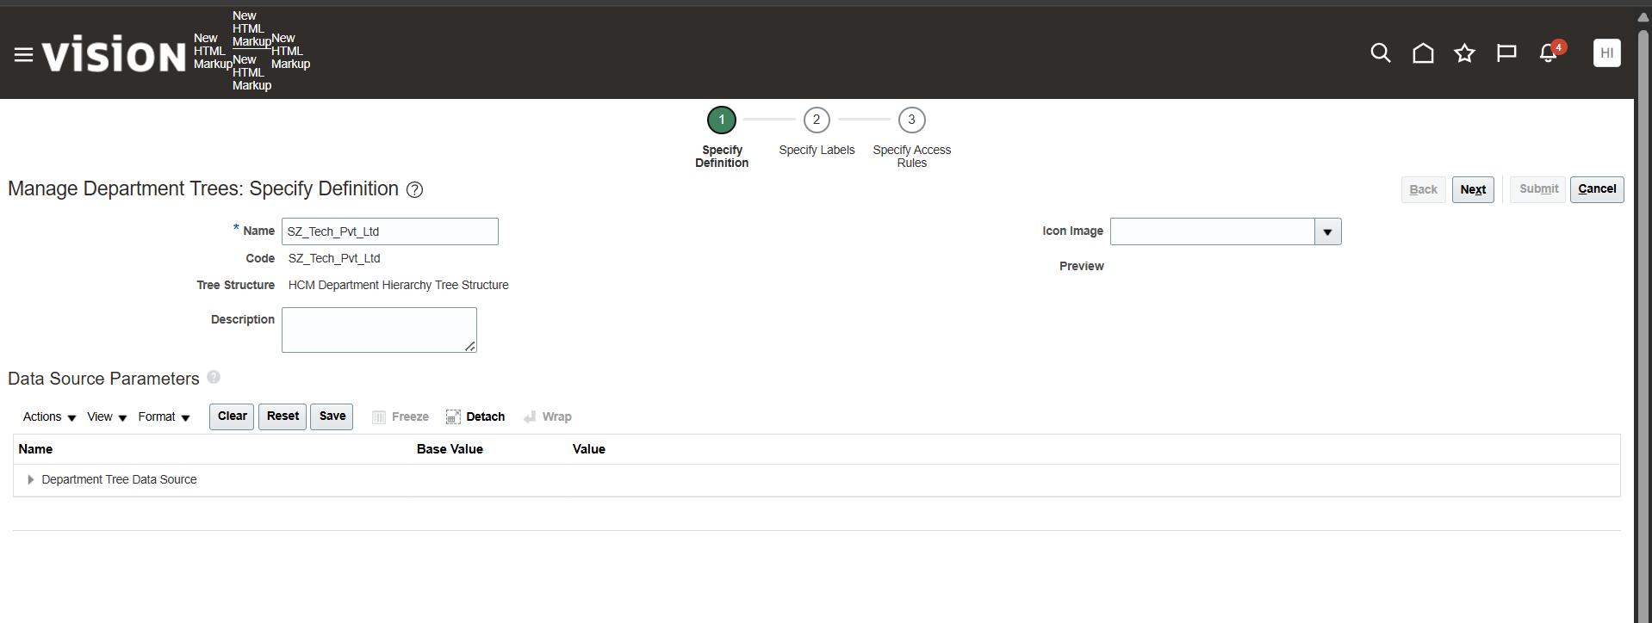

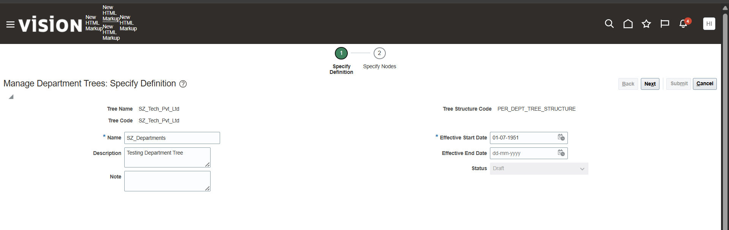

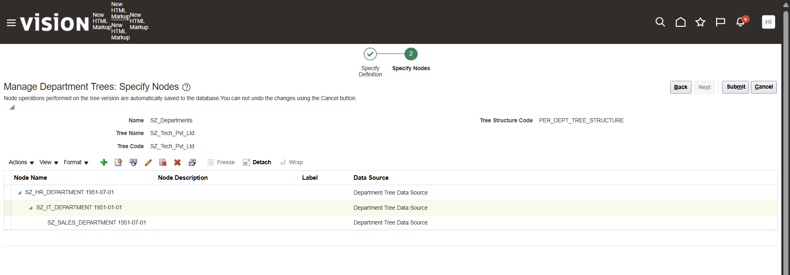

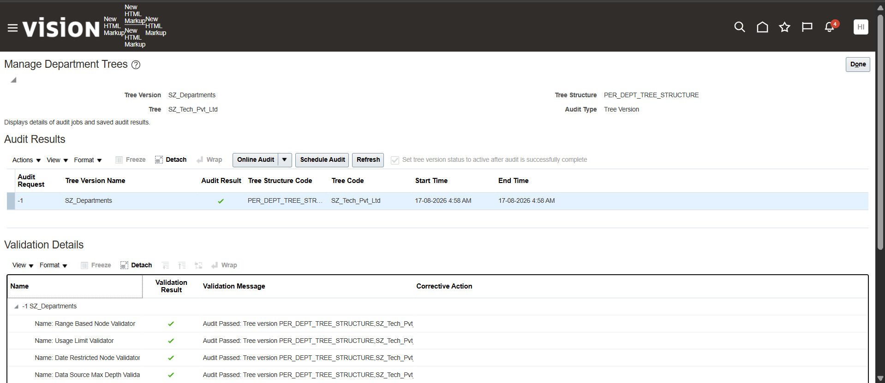

Step 11: Location Creation
Define the physical locations where your employees will work. Locations are set-enabled, so you will attach them to your custom Reference Data Set.
Navigation: Setup and Maintenance > Search Task: Manage Locations
- Task: Create Location
- Location Name: SZ_US_Location
- Location Code: SZ_US_LOC
- Set: SZ_RDS
- Status: Active
- Main Address: 9077 San Francisco River Rd, 85533Clifton, AZ, Greenlee UNITED STATES
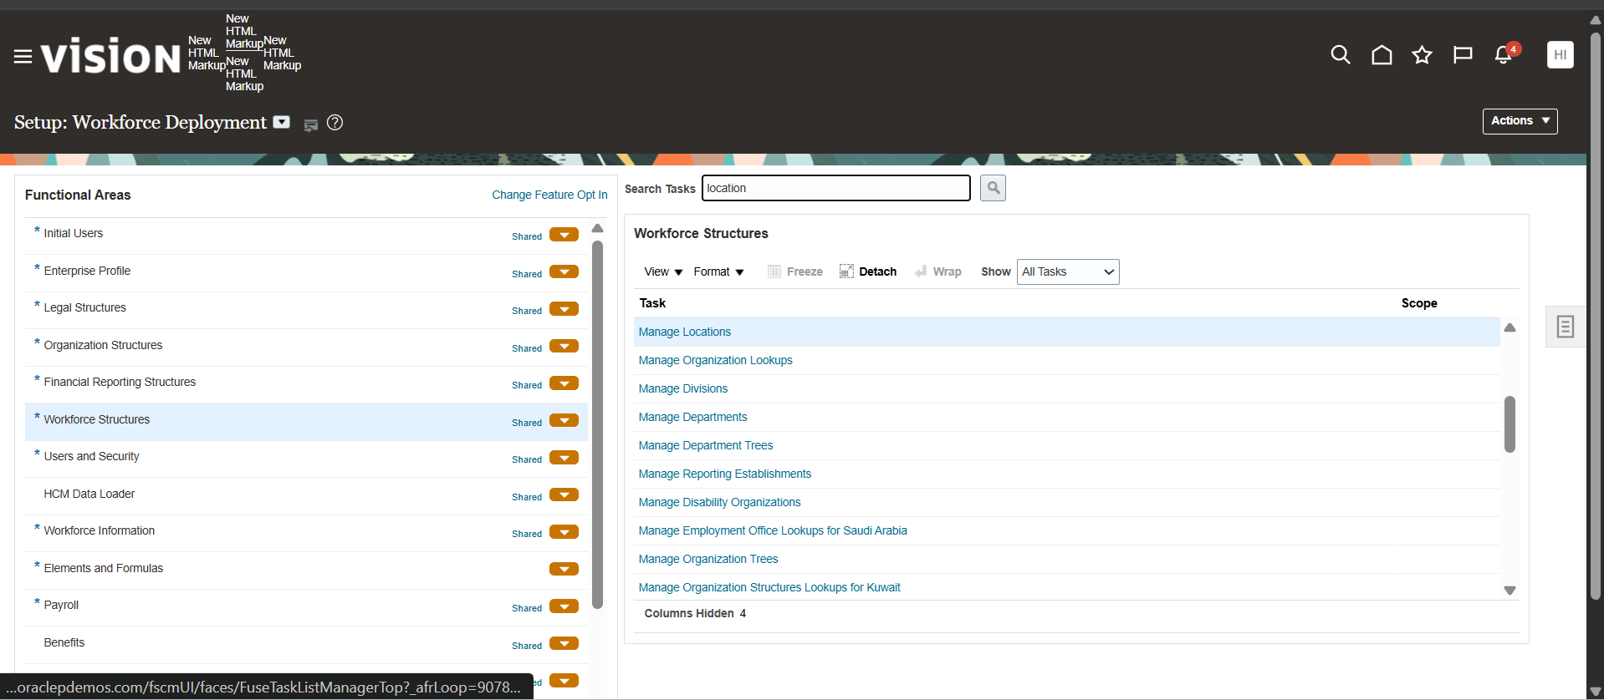
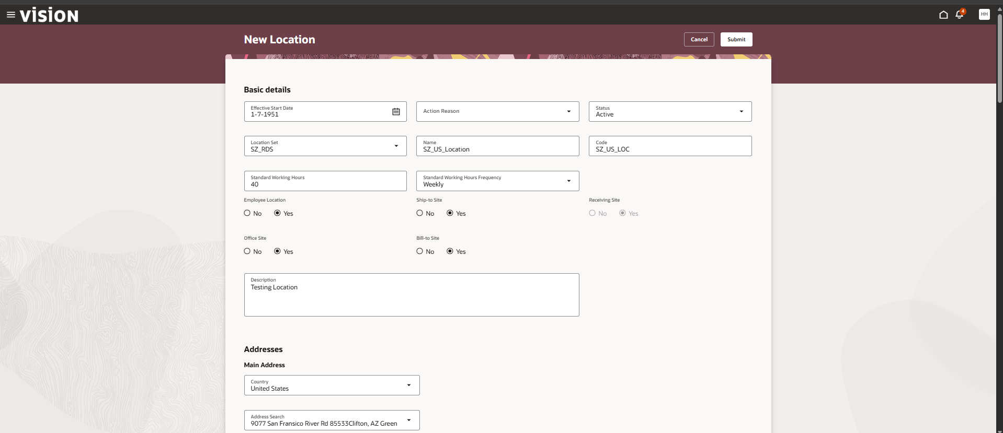

Step 12: Job Setup : Create Job Family and Job
Jobs represent generic roles (e.g., Software Engineer, HR Specialist) independent of specific departments or locations.
Navigation: Setup and Maintenance > Search Task: Manage Job Families
Basic Details:
- Effective Start Date: 1-7-1951
- Status: Active
- Name: SZ_JOB_FAMILY
- Code: SZ_JOB_FAMILY
Navigation: Setup and Maintenance > Search Task: Manage Jobs
- Task: Create Job
- Name: SZ_HR_Specialist / SZ_IT_Engineer / SZ_Sales_Executive
- Code: SZ_JOB_HR_SPEC / SZ_JOB_IT_ENG / SZ_JOB_SALES_EXEC
- Set: SZ_RDS
- Status: Active
- Effective Start Date: 1-7-1951
- Job Family: SZ_JOB_FAMILY
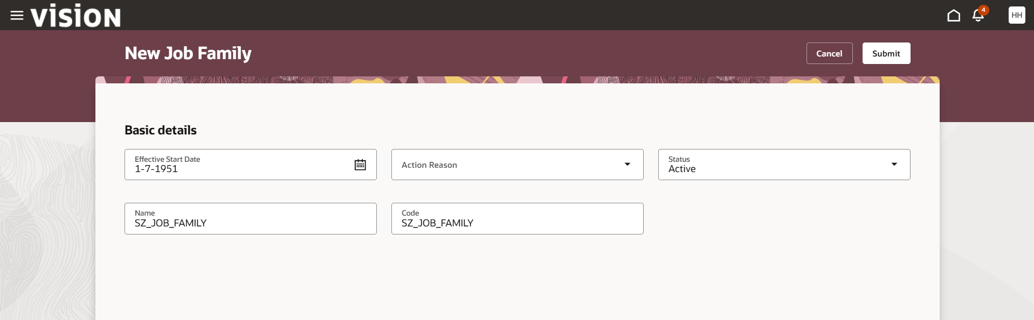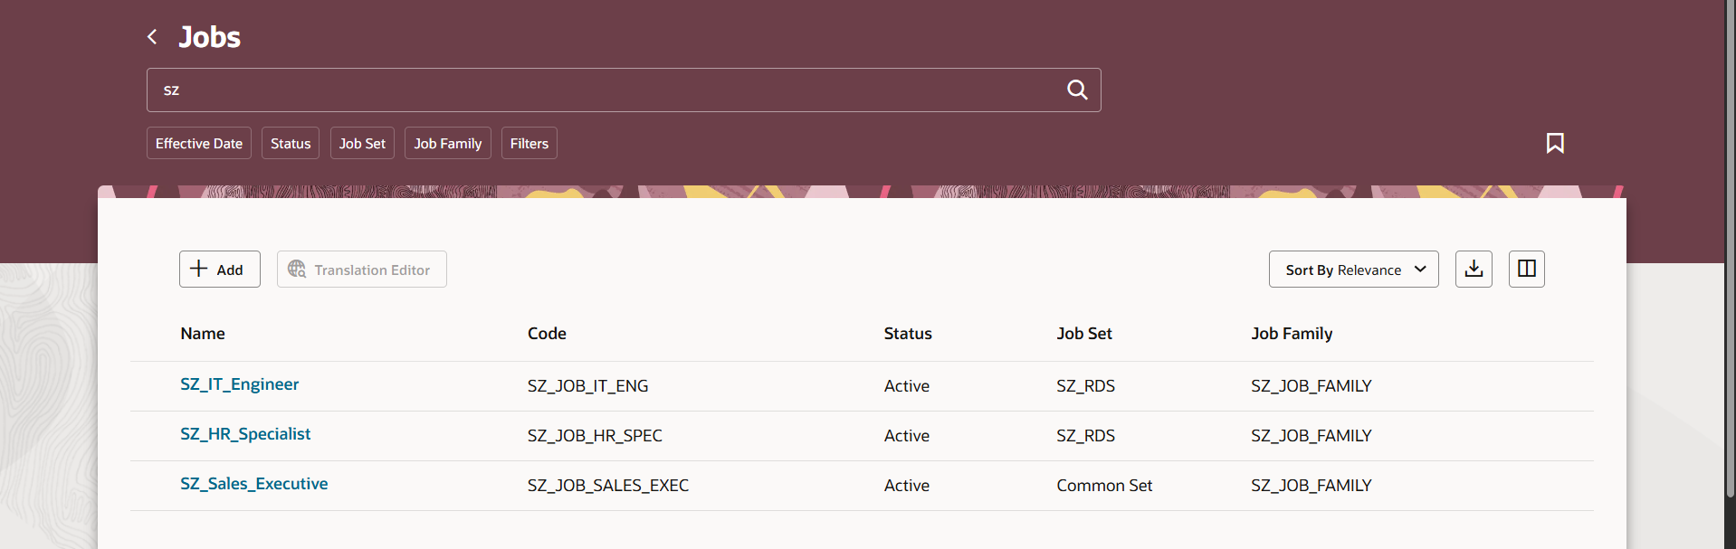
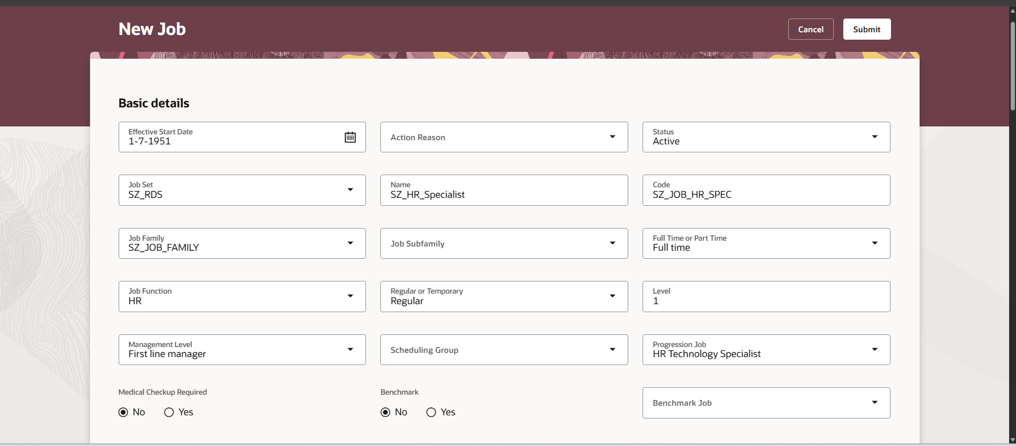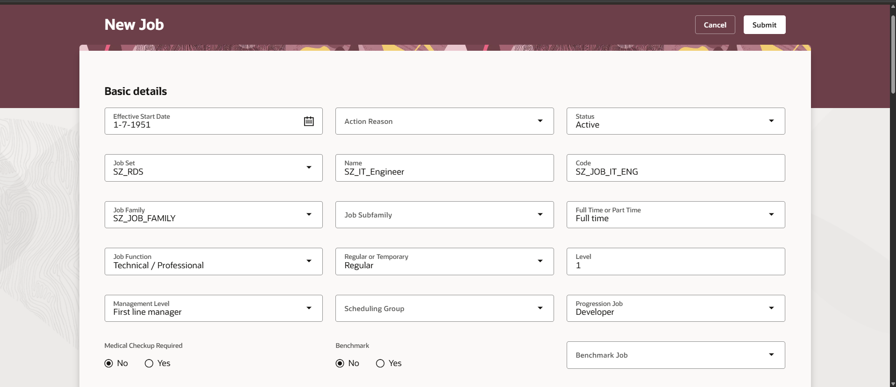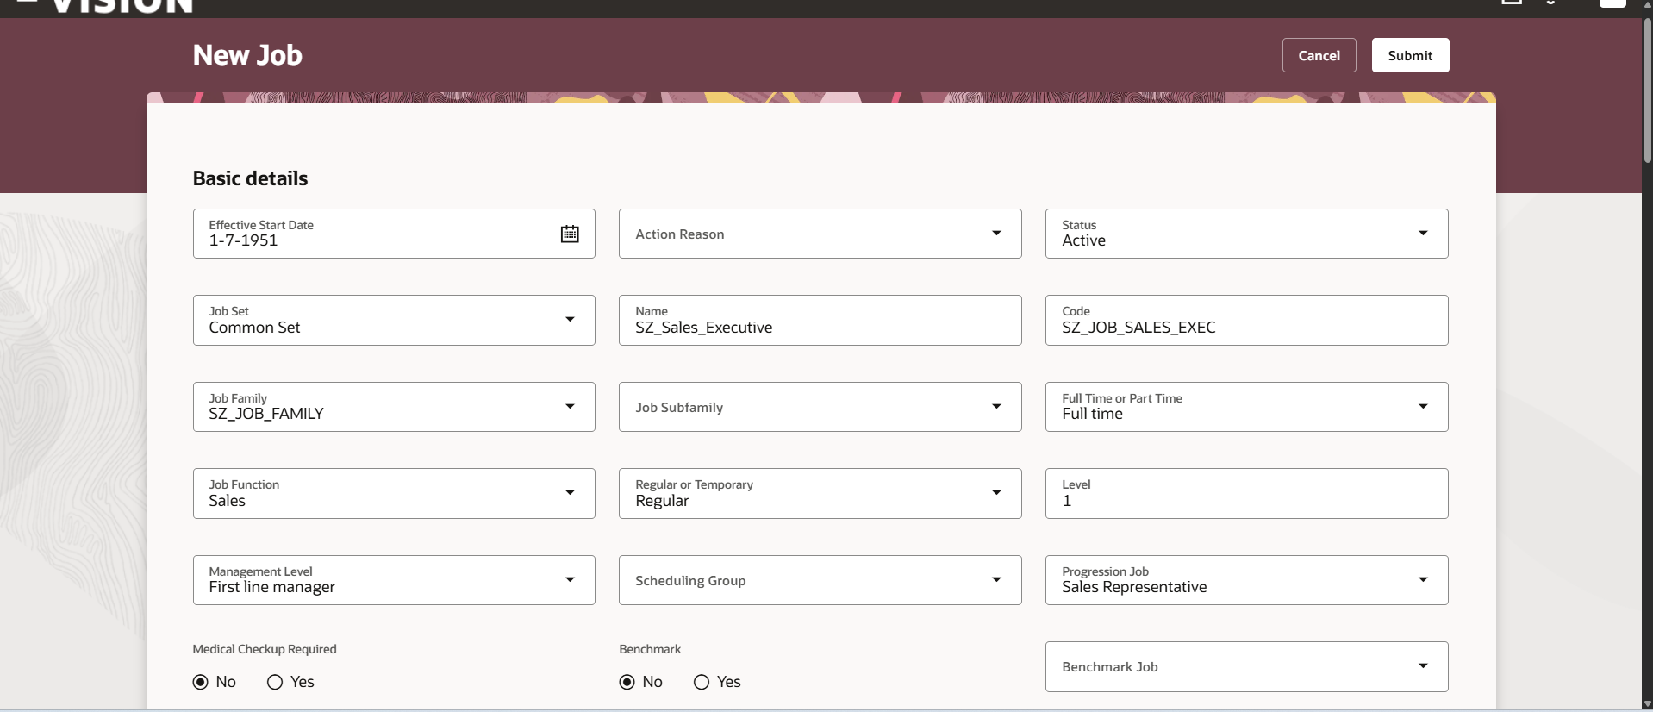

Step 13: Position Setup
Positions are specific, headcount-tracked instances of a job within a specific department and location
Navigation: Setup and Maintenance > Search Task: Manage Positions
- Task: Create Position
- Business Unit : SZ_US_BU
- Position Name: SZ_HR_Specialist_Pos / SZ_IT_Engineer_Pos / SZ_Sales_Exec_Pos
- Business Unit: SZ_US_BU
- Job: SZ_HR_Specialist/ SZ_IT_Engineer/ SZ_Sales_Exec
- Department: SZ_HR_DEPARTMENT/ SZ_IT_DEPARTMENT/ SZ_SALES_DEPARTMENT
- Location: San Francisco
- FTE / Headcount: Set target headcount (e.g., Headcount: 1, FTE: 1.0)
- Status: Active
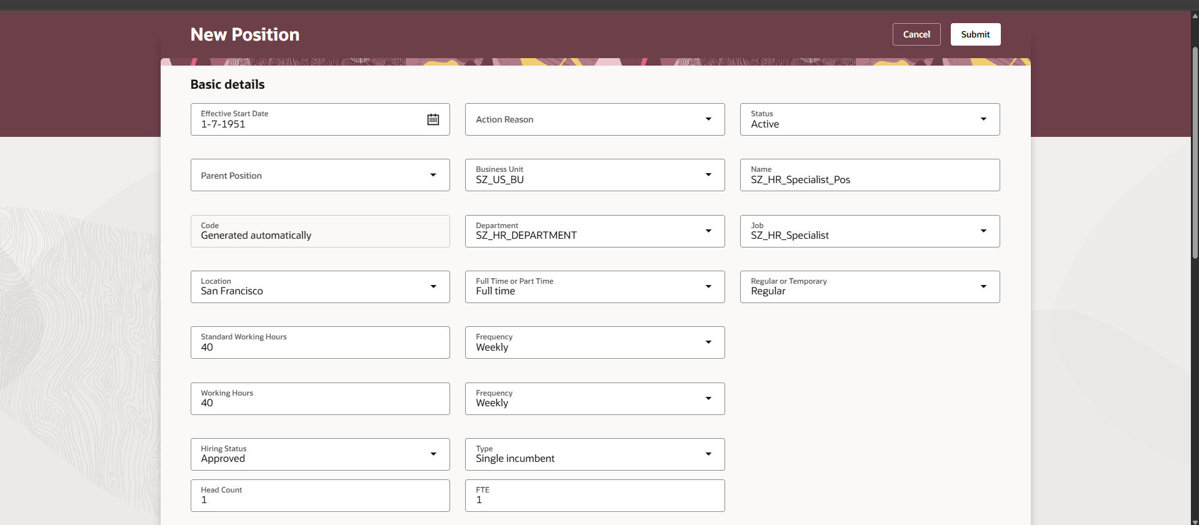
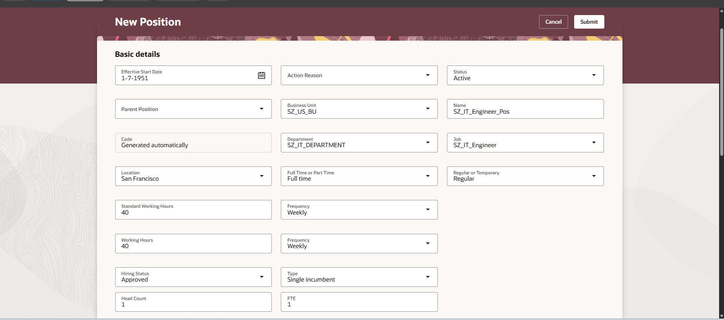
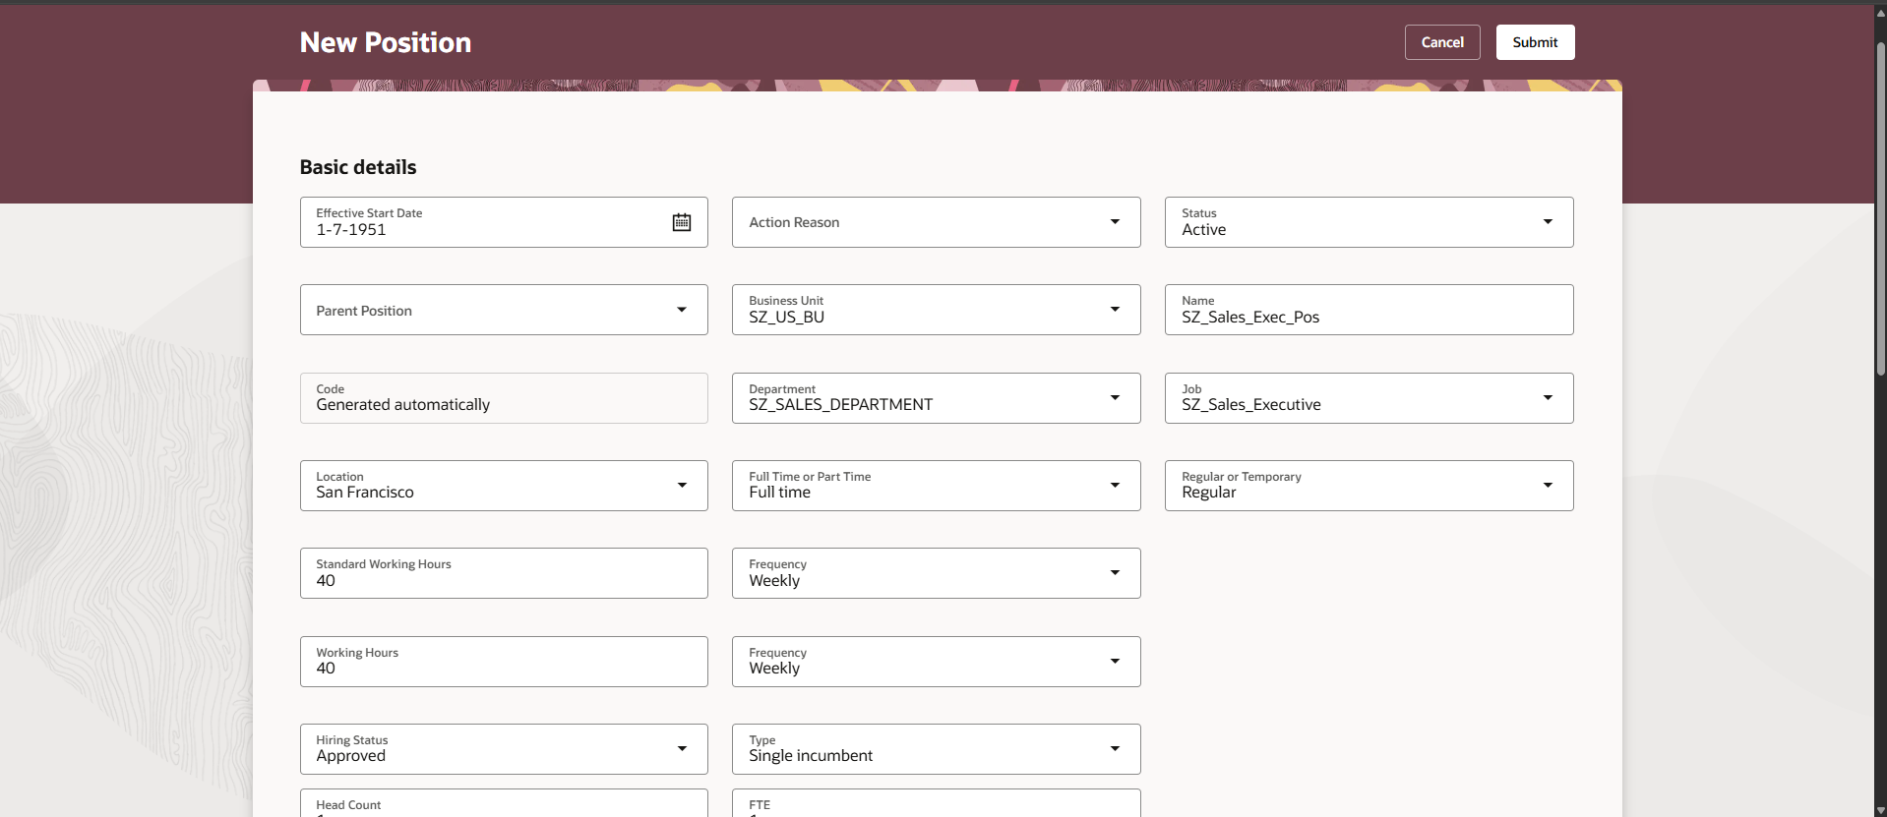

Summary Matrix :

Setup Object / Task | Object Name / Title | Code / Identifier | Key Parameters & Mappings
Implementation Project | SZ Tech Pvt. Ltd. | SZ_TECH_PVT_LTD | Assigned To: HCM_IMPL
Reference Data Set | SZ_RDS | SZ_RDS | Task: Define Reference Data Sharing for HCM
Legislative Data Groups | SZ_US_LDG  SZ_IND_LDG | SZ_US_LDG  SZ_IND_LDG | US: United States / US Dollar  India: India / Indian Rupee
Legal Jurisdiction & Authority | SZ_US_LJ  SZ_US_LA | SZ_US_LJ  SZ_US_LA | Category: Commercial Law | Territory: United States  Tax Authority Type: Collecting the reporting  Address: YU LINE 4, TEXAS CITY, IL Saline
Legal Entity (PSU / LE) | SZ_US_LE | SZLE9763 | Classifications: PSU & Legal Employer  Model: 2 Tier - Single Contract - Single Assignment  LDG: SZ_US_LDG | Calculation Card Effective: 1/7/51
Legal Reporting Unit (LRU) | SZ_US_LE | SZ_US_LE | Classifications: Tax Reporting Unit (TRU) & Reporting Establishment  Calculation Card attached to TRU
Primary Ledger | SZ_PL | SZ_PL | COA: IN Chart of Accounts | Currency: USD  Calendar: Annual Calendar | Method: US Federal  LE Assignment: Mapped SZ_US_LE
Business Unit | SZ_US_BU | SZ_US_BU | Default Set: SZ_SET_CODE
Departments | HR Department  IT Department  Sales Department | SZ_HR_DEPARTMENT  SZ_IT_DEPARTMENT  SZ_SALES_DEPARTMENT | Linked Set: SZ_RDS
Department Tree | SZ_Tech_Pvt_Ltd | Version: SZ_Departments | Effective Start Date: 1/7/51  Nodes: HR, IT, & Sales Departments  Status: Audited (14/14 pass) & Flattened
Location | SZ_US_Location | SZ_US_LOC | Set: SZ_RDS | Designation: Site & Office | Country: US
Job Family | SZ_JOB_FAMILY | SZ_JOB_FAMILY | Effective Start Date: 1-7-1951 | Status: Active
Jobs | SZ_HR_Specialist  SZ_IT_Engineer  SZ_Sales_Executive | SZ_JOB_HR_SPEC  SZ_JOB_IT_ENG  SZ_JOB_SALES_EXEC | Set: SZ_RDS | Effective Date: 1-7-1951  Job Family: SZ_JOB_FAMILY | Benchmark Job: No
Positions | SZ_HR_Specialist_Pos  SZ_IT_Engineer_Pos  SZ_Sales_Exec_Pos | Auto-generated | BU: SZ_US_BU | Loc: SZ_US_Location  Effective Date: 1-7-1951 | Status: Approved / Active  Hours: 40/wk (Full time / Regular)

